

CSA0501-DATABASE MANAGEMENT SYSTEMS

LAB EXPERIMENTS DATE: 12/07/2026

EXPERIMENT 3 – DML Commands (INSERT, SELECT)

AIM:
To perform Data Manipulation Language (DML) commands such as INSERT and SELECT in the DAIRY Management System database.

PROCEDURE:
- Open MySQL and create the dairy Management System database.
- Create the dairy details table with appropriate attributes.
- Use the INSERT command to add dairy records into the table.
- Execute the SELECT command to display all pet records.
- Verify that the inserted data is displayed correctly.
- Observe the output and ensure the DML commands are executed successfully.

PROGRAM:

1. CREATE TABLE:

CREATE TABLE dairy(

name VARCHAR(30),

liters INT(40),

Amount BIGINT(20),

Account_number BIGINT(30),

Phone_number BIGINT(12)

Bank_name VARCHAR(20)

);

OUTPUT:

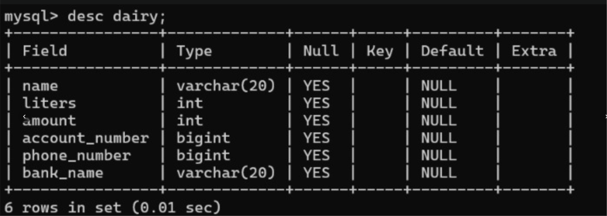

2. INSERT VALUES:
INSERT INTO DAIRY VALUES

('Shanthi', 5, 320, 9679411723, 8639516519, 'SBI'),
('Nagu', 4, 290, 4192233411, 7182111462, 'SBI'),
('Sai', 7, 500, 497481234, 7670972570, 'SBI'),
('Venu', 9, 650, 727446123, 9204639364, 'Canara'),
('Sugana', 10, 700, 825849623, 6305857568, 'Andhra'),
('Sekar', 8, 600, 889241729, 9180091111, 'SBI'),
('Kamala', 15, 1500, 6284942417, 9132277911, 'SBI'),
('Ramu', 11, 950, 723967941, 8918286963, 'SBI'),
('Sita', 9, 650, 5492411763, 9350005229, 'Andhra'),
('Laxmi', 4, 290, 46418234748, 891991835, 'Canara');

OUTPUT:

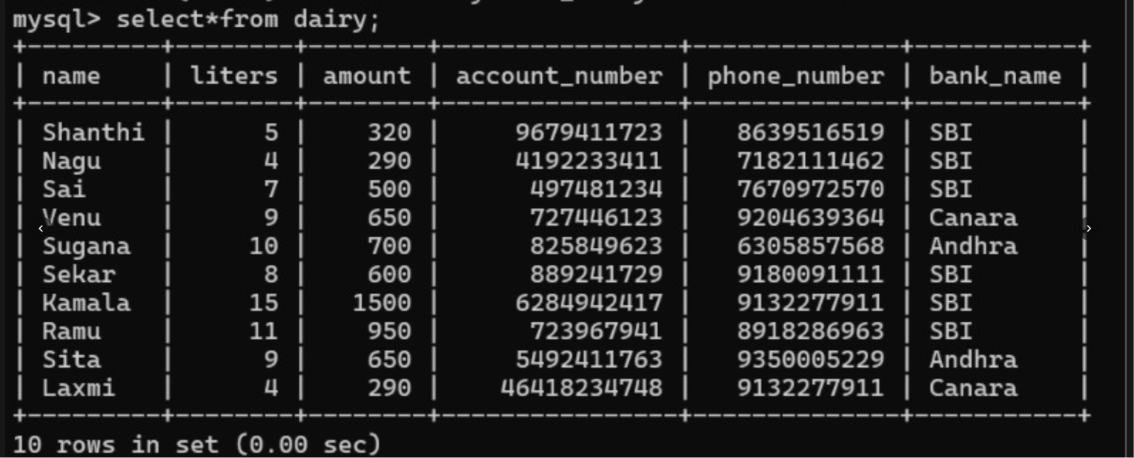

3. INSERT COMMAND:
SELECT * FROM dairy;

INSERT INTO dairy(name,liters,amount,account_number,phone_number,bank_name)

VALUES (‘priya’,4,420,8765432190,9345678123,’SBI’);
OUTPUT:

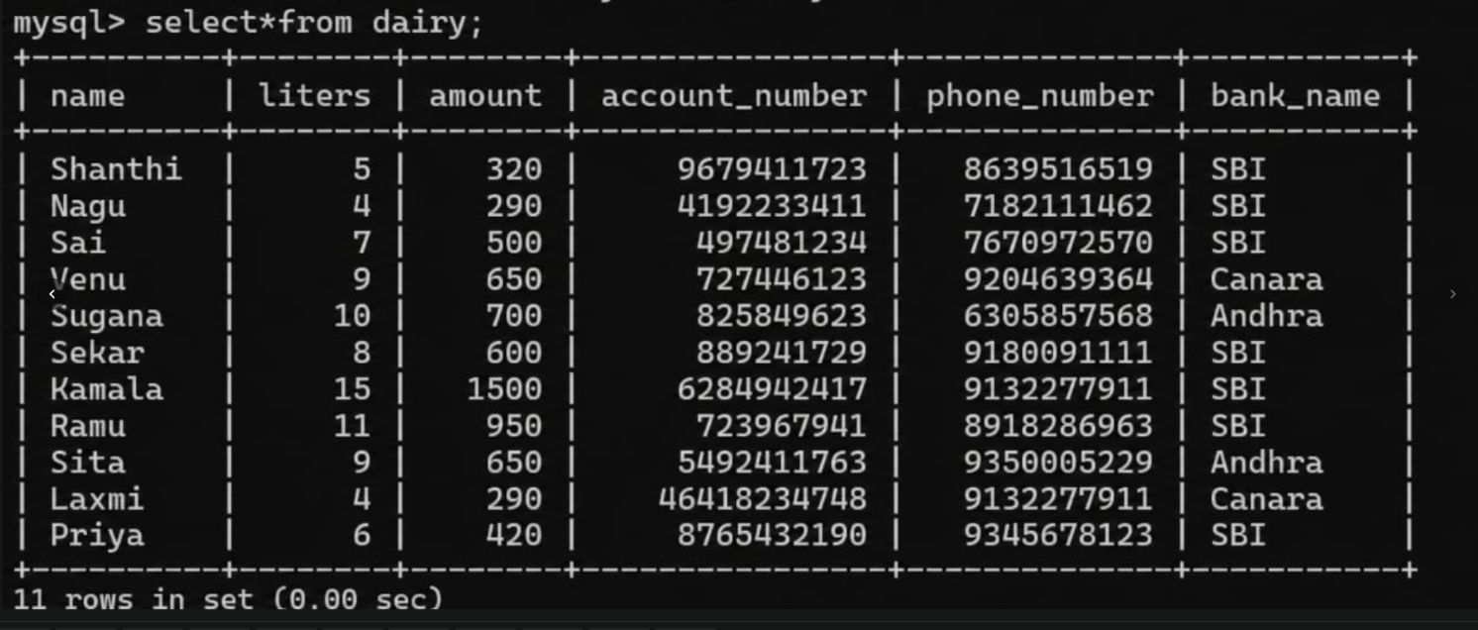
4. SELECT COMMAND:

SELECT * FROM dairy;
OUTPUT:


RESULT: Data Manipulation Language (DML) Commands such as INSERT, SELECT are performed

